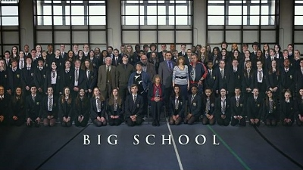
Big School is a British sitcom, starring David Walliams, Catherine Tate, Steve Speirs, Frances de la Tour and Philip Glenister. It is set in a secondary school and follows the comedic relationships of the teachers
The series follows Keith Church (David Walliams), a socially naive chemistry teacher at the fictional Greybridge Secondary School, near Watford, North London, who falls for new French teacher Sarah Postern (Catherine Tate), who believes herself to be an inspirational teacher, in tune with youth culture and a beautiful woman.
- While you are watching, write down the missing words in the subtitles
1. | 9.
2. | 10.
3. | 11.
4. | 12.
5. | 13.
6. | 14.
7. | 15.
8. | 16.

- After you’ve watched the episode, answer this question.
Some typically British words are used in this episode. Explain what these words mean (in English) and explain when they are used (in which situation).
Word | Meaning | Used
Daft
Lavatory
Utter
Bollocks
Jack-the-lad
Lager

